Wilts C. Alexander, III
15745 Acorn Circle | Tavares, FL 32778| Mobile: 678-428-5997
wiltsalex@asaglobal.com| www.linkedin.com/pub/wilts-alexander/5/b39/998
Executive Biography
Consulting and Coaching for Individual, Team, and Organization Transformation
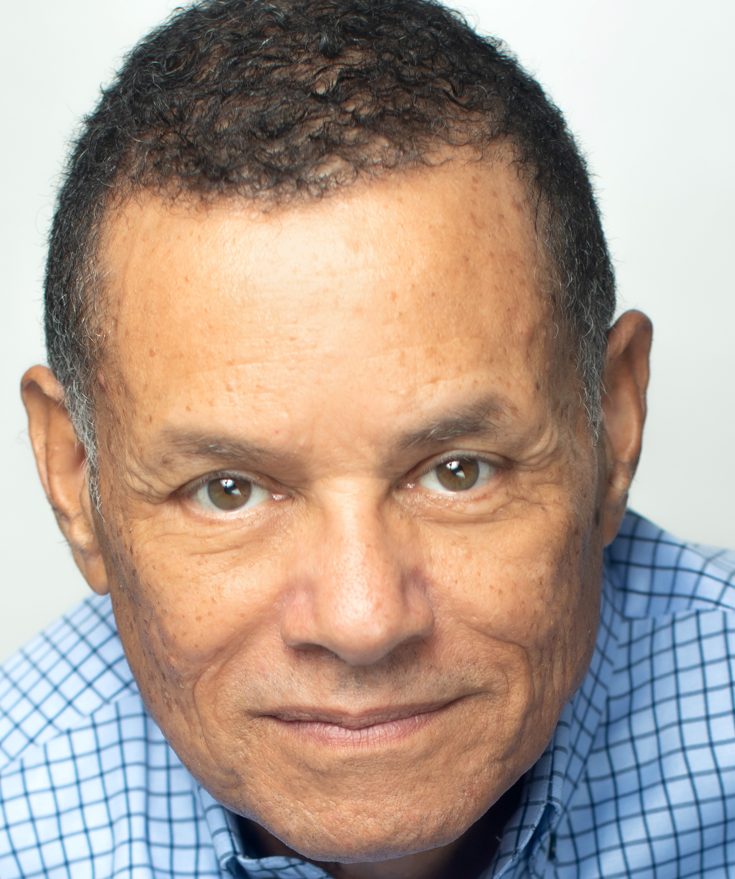
A recognized leader in the field of organizational transformation and leadership development, Wilts has devoted the last decade of his career to mastering the art and science of coaching Executives and business owners to achieve higher levels of Leadership and Effectiveness. As the president of Alexander, Scott & Associates, he has influenced the development of American, European, and Asian companies and their leaders. This global experience allows him to understand the roles, responsibilities, and requirements of being an effective executive in a dynamic marketplace. In addition, his coaching style and coaching expertise allow him to be very effective in working with busy executives and entrepreneurs.

An acknowledged management coach, consultant, and facilitator, he continues to support the development of high-potential managers to bridge the gap between their current positions and ambitions. Wilts’ passion is transforming managers and entrepreneurs into leaders by improving their ability to think systemically, focus on value creation, design and develop high-performance organizations, improve execution, and manage the soft side of change.

His successful coaching projects include:

- Coaching real estate business owners and teams of entrepreneurs to achieve business and lifestyle goals by addressing specific “ inner Game and Personal Effectiveness” challenges.
- Successfully consulting and coaching the owners and CEO through acquiring and reinstating a 120-year bottling operation in the country.
- Leading the transformation of a global computer customer service business into a multivendor service business and implementing a cultural change program in 117 countries, affecting 160,000 employees.
- Performance and accountability coaching for high net-worth members.
- Guiding a cross-functional team of emerging leaders in developing a 30-year scenario-based strategic plan that included reducing the cost of operation, optimizing throughput, sustainability, and cultural change for Alyeska Pipeline.
- Coach the Provost Office of the University of Alabama to develop and implement a student retention and persistence model to increase four and six-year graduation. Developing the organizational design for the world’s largest state-of-the-art continuous cold roll aluminum mill, including developing and delivering training for the startup teams.

Wilts has developed and applied practical techniques to build high-performance organizations and leaders. His early work in Procter and Gamble and with leading thinkers (including Peter Senge, Lou Davis, Jim Taylor, Jim Selman, William Passmore, Richard Beckhard, and Richard Walton) influenced his introduction of designing and leading high-performance organizations as a pioneering approach that produce paradigm shifts in the corporate world. This methodology has been a strategic program for leadership development and growing the leadership pipeline for many companies.

With clients such as The Coca-Cola Company, Coke Canada Bottling, Ebony Magazine, Fynanc Academy, Novartis Animal Health, Ceves Agro Food Products, the University of Alabama, and many SMBs, Wilts’ leadership and expertise have supported major transformational programs and executive leadership development.

